- INTRODUCTION TO LADDERS AND STEPLADDERS
Ladders and stepladders are commonly used for working at heights. It is therefore important to have ladders and stepladders of good quality and to use, move and store them in a correct manner.

- EXPLANATION & RISKS
- Using a ladder is allowed:  - to move to a limited higher or lower level  - for inspection or monitoring at limited height (no work)  - for certain activities:  - with standing height < 2m -2.5 m (or stricter)  - without exerting great effort or force (100N)  - without handling heavy loads (max 10 kg) | Examples:  to go on the roof of a  ground floor shop whereby the ladder is sticking out sufficiently above the flat roof  inspection (looking from above the ladder) of works, condition of a roof, ...  painting work with maximum standing height of 2m  replacing light bulbs, with maximum standing height of 2m  …
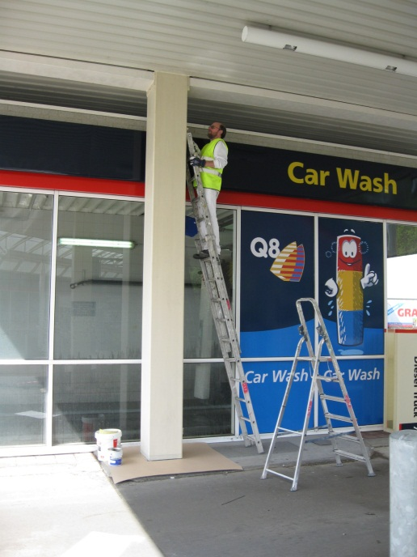
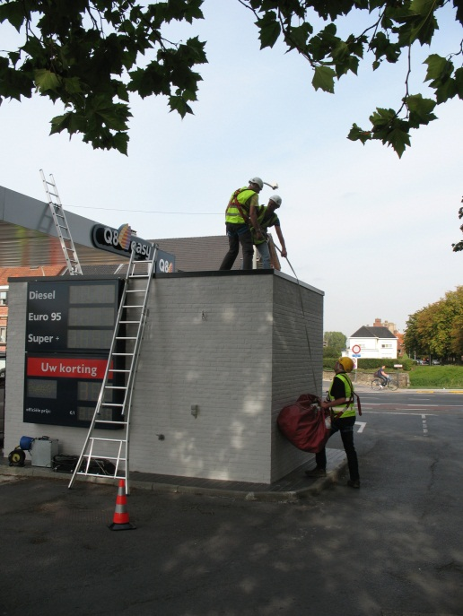



2m

- The following risks are present using ladders/stepladders

- Risk of falling: when/if ladders are not properly set up and/or climbed incorrectly: because one works with 2 hands simultaneously, because too heavy loads are taken, etc.
- Risk of pinching: between parts of and under the ladder, often the preparation and also when falling from/with the ladder
- Electric contact (shock): by using an incorrect type of ladder or by taking insufficient electric precautions

- SAFETY REQUIREMENTS
- ALWAYS USE THE RIGHT LADDER FOR THE RIGHT JOB
- material: wood, metal, aluminium or plastic ladders
- type: single, double, slip, slide, stepladders, ...
- always CE certified and approved
CHECK

- PERSONAL PROTECTIVE EQUIPMENT
- safety shoes or -boots
- SIGNAGE – INDICATE THE WORKPLACE


- cones
- and/or ground pictographs
- CHECKS BEFORE USE
- Always a clean ladder, no dirt on the ladder
- no folds or deformations, even no cracks
- no missing, loosening, worn, cracked, decayed or ripped rungs
- no clear contamination by chemicals whereby the strength of the separate parts of the ladder is reduced
- not frayed or cracked connection cords
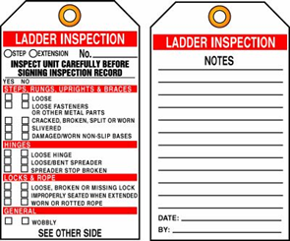
- perfect state of hinges and brackets
- perfect state of anti-slip provisions
- inadequate ladder (e.g painted hinges)- it may hide defects
- REGULAR INSPECTION OF THE LADDER
- by a competent worker (who has the required knowledge and followed adequate training)
- with label on ladder so one can check until when the inspection is valid

HOW TO SET UP A LADDER?
CHECK
- PREFERABLY 2 PERSONS TO SET UP A LADDER
- SET THE LADDER AT AN ANGLE OF ABOUT 75 DEGREES
TIP: a ladder is in the correct position when you can touch the rungs with your hands while your toes are touching the bottom side of the rungs
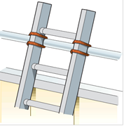
- MAKE SURE THAT THE LADDER PROTRUDES AT LEAST
1 METRE AT THE TOP WITH FLOOR HOLES AND ROOF EDGES
- SECURE THE LADDER AT THE TOP AGAINST SLIDING OR SECURE THE LADDER WITH A ROPE OR OTHER FIXING DEVICE
- IF NECESSARY PROVIDE A STABILISATION BAR AT THE BOTTOM TO PREVENT SLIDING
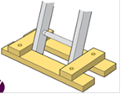

HOW TO USE A LADDER?
CHECK

- ONLY TRAINED WORKERS
Via registered and documented instruction
(how to use, risks, what is not allowed, ...)
- ALWAYS CLIMB AND DESCEND LADDERS WITH:
- two hands on the steps or along the rungs
- the body between the uprights
- face sideways and towards the direction you are going to
- WORKING ON LADDERS:
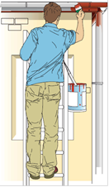
- always keep 2 feet on the same step and 1 hand on the ladder (on a step or a rung at the side of the rung)
- maximum at 1 arm length when standing straight on the ladder
- STAY AT LEAST 4 RUNGS FROM THE TOP

KUWAIT PETROLEUM NORTH WEST EUROPE

DOCUMENT TITLE: TSR - Working at height - Ladders

DOCUMENT NUMBER: KPNWE.WI.11.HSCO.047

REVIEW NUMBER: 1

EFFECTIVE DATE: 13 Jul 2020

NEXT REVIEW DATE: 13 Jul 2023
..

CONFIDENTIALITY:
The information contained in this document is confidential to Kuwait Petroleum International Ltd. Copyright © Kuwait Petroleum International Ltd. Copying of this document in any format is not permitted without written permission from the management of Kuwait Petroleum International Ltd.

This document is reviewed and approved according to the released online Document Approval Flow

Prepared by: | Operational Assistant | An Cornelis
Reviewed by: | Operational Assistant | An Cornelis
Approved by: | QHSSE Manager | Gerardus Timmers

*Access rights: Generally Accessible

Reviews Summary

Review date | Review reference | Review details | Review version
01 Dec 2017 |  |  | 0
13 Jul 2020 | -- | minor changes | 1

